A

Project Report on

# Portfolio With Chat bot integration

Submitted in partial fulfilment of completion of the course

Advanced Diploma in IT, Networking and Cloud

Submitted by:

**Prateek Kumar**

Under the Guidance of:

**(Edunet Mentor) Mrs Deepika singh**

|  |  |  |
| --- | --- | --- |
| IBM-Logo - Chicago Innovation | DGT introduces high end diploma courses - digitalLEARNING Magazine | Edunet Foundation-Delhi- CSR Organization profile |

Year 2024

# Acknowledgement

We take this occasion to thank God, almighty for blessing us with his grace and taking our endeavor to a successful culmination. We extend our sincere and heartfelt thanks to our esteemed guide, **Smt. Deepika Singh** for providing us with the right guidance and advice at the crucial junctures and for showing me the right way. We also take this opportunity toexpress a deep sense of gratitude to our Trade faculty Staff **Mrs. Ankita Shukla** for their cordial support, course coordinator **Mr. D.A. Guruvulu** ,valuable suggestions and guidance. We extend our sincere thanks to our respected **Head of the division *Smt. Shashi Mathur [JD NSTI(W) NOIDA]***, for allowing us to use the facilities available. We would like to thank the other faculty members also, at this occasion. Last but not the least, we would like to thank our friends and family for the support and encouragement they have given us during the course of our work.

|  |  |  |
| --- | --- | --- |
| Sr No | Table of Contents | Pages |
|  | Introduction to Problem |  |
|  | Literature Review |  |
|  | Proposed Solution |  |
|  | Requirements  4.1 Technology Stack  4.2 Hardware  4.3 Software  4.4 Deployment Environment |  |
|  | User Requirements |  |
|  | Implementation Details |  |
|  | Testing |  |
|  | Deployment |  |
|  | Conclusion |  |
|  | Appendix A Project Code |  |
|  | Appendix B Screenshot of Project |  |
|  | References |  |

1. **Introduction to Problem**

In today's fast-paced digital environment, portfolios have evolved beyond mere static displays, transforming into dynamic reflections of personal and professional identities. The infusion of chatbots into this landscape presents an exhilarating opportunity for enhanced user engagement but concurrently introduces a distinct challenge. The integration of chatbots necessitates meticulous execution to strike a delicate balance. While these AI-driven conversational agents hold the potential to elevate user interaction and portfolio functionality, a thoughtful approach is imperative to prevent disruption to the user experience. This introduction aims to explore the intricate equilibrium essential for effectively harnessing the capabilities of chatbot technology within portfolios, fostering innovation while preserving a seamless and user-friendly environment. As we navigate this intersection of technology and personal expression, the following discourse will delve into the nuanced considerations and strategies required to capitalize on the benefits of chatbot integration in portfolios.

1. **Literature Review**

The integration of chatbots within portfolios stands at the forefront of a rapidly evolving field, situated at the convergence of digital communication and personal branding. In the existing literature, a paramount emphasis is placed on achieving seamless user experiences, recognizing that the success of chatbot integration hinges on its ability to complement rather than disrupt user interaction. Technological considerations, particularly in the realm of natural language processing, are explored to unravel the intricacies of effective communication between users and chatbots. Ethical dimensions are also scrutinized, with scholars delving into concerns surrounding privacy, transparency, and the responsible use of AI in personal and professional contexts.

Moreover, the literature underscores the transformative potential of chatbots in personalization and customization, demonstrating how tailored interactions can significantly enhance user engagement within portfolios. Researchers have probed the implications of chatbot-driven personalization on professional representation, offering insights into the evolving nature of digital identities. This comprehensive review illuminates the multifaceted aspects of chatbot integration within portfolios, serving as a foundational framework for deeper analysis. As we navigate the juncture of technology and personal branding, this literature review sets the stage for a nuanced exploration, guiding subsequent discussions and recommendations for the effective and ethical integration of chatbots into the realm of professional representation.

1. **Proposed Solution**

Utilizing IBM Watson services on the cloud, the solution involves optimizing the chatbot integration into the portfolio.

1. **User-Focused Design:** Prioritize an intuitive interface, ensuring the chatbot complements the portfolio content. Enable user control over interactions for a seamless experience.
2. **Enhanced NLP Capabilities:** Leverage advanced Natural Language Processing (NLP) from IBM Watson to improve the chatbot's conversational abilities, enhancing language comprehension and response relevance.
3. **Personalization Features:** Harness Watson's capabilities to offer personalized interactions, tailoring responses based on user preferences and objectives for a more engaging experience.
4. **Requirements** 
   1. **Technology Stack Full stack development**

Frontend:

* HTML
* CSS
* JavaScript

Integration Services:

* IBM Watson Assistant (for chatbot functionality)
* IBM Cloud Object Storage (for file storage)
  1. **Hardware**

• Desktop/Laptop

• Internet Connection

* 1. **Software**

Text Editor:

* Visual Studio Code: A lightweight, powerful code editor with great support for HTML, CSS, and JavaScript. It has extensions that can enhance your development experience.

Web Browser:

* Google Chrome, Mozilla Firefox, or Microsoft Edge: Browsers for testing and previewing your portfolio. They have built-in developer tools for debugging and inspecting your code.

IBM Cloud Account:

* IBM Cloud Account: Sign up for an IBM Cloud account to use Watson Assistant and Cloud Object Storage. You'll access these services through the IBM Cloud platform.
  1. **Deployment Environment**

IBM Cloud Object Storage (COS) is a scalable and secure cloud storage solution provided by IBM. It is designed to handle vast amounts of unstructured data efficiently. Leveraging a flexible architecture, COS allows organizations to store and retrieve data seamlessly, catering to diverse needs.

COS provides high durability and availability, ensuring data reliability and accessibility. It employs a unique technology called "information dispersal," breaking data into slices and distributing them across multiple geographic locations. This enhances data resilience and minimizes the risk of data loss.

IBM COS supports various storage classes, enabling users to choose the most cost-effective option based on their data access patterns. It seamlessly integrates with other IBM Cloud services and offers compatibility with various data transfer protocols, facilitating smooth data workflows.

With robust security features, including encryption at rest and in transit, access controls, and audit logging, IBM COS ensures the confidentiality and integrity of stored data. Additionally, it provides a simple and scalable solution for managing large-scale data storage requirements in diverse deployment environments, making it a versatile and reliable choice for organizations embracing cloud-based storage solutions.

1. **User Requirements**

The user requirements for the proposed chatbot-integrated portfolio solution are straightforward and designed for maximum accessibility:

1. **\*\* Mobile Devices:\*\***

Users can access the chatbot-infused portfolio solution from various electronic devices, including mobile phones, laptops, desktop computers, and tablets. This ensures flexibility and convenience, allowing individuals to engage with their portfolio on the device of their choice.

1. **\*\*Browser:\*\***

The solution is web-based, requiring users to have a standard web browser installed on their electronic device. This browser compatibility ensures a broad range of accessibility across different platforms, such as Chrome, Firefox, Safari, or Microsoft Edge.

1. **\*\*Access to Internet:\*\***

Users need an internet connection to access and interact with the chatbot-infused portfolio. The cloud-based nature of the proposed solution, especially if leveraging IBM Cloud services, ensures that users can seamlessly connect to the portfolio and chatbot functionalities online.

By keeping the user requirements minimal and widely compatible, the solution aims to maximize accessibility, allowing users to engage with their portfolios and the integrated chatbot across diverse electronic devices and internet-connected environments. This approach aligns with the goal of creating a user-friendly and inclusive experience for individuals with varying preferences and technological setups.

1. **Implementation Details**

**Creating a portfolio using HTML, CSS, and JavaScript and integrating it with an IBM Cloud chatbot involves a step-by-step process. Here's a general outline:**

**1. **Portfolio Design and Development:\*\***

**-** Create the structure of your portfolio using HTML, defining sections such as bio, projects, skills, and contact information.

- Style your portfolio using CSS to enhance its visual appeal and ensure a responsive design that works well on various devices.

- Implement interactivity using JavaScript to enhance user experience, such as dynamic content loading or interactive elements.

**2. **IBM Cloud Account Setup:\*\***

- Sign up for an IBM Cloud account if you don't have one already.

- Navigate to the IBM Watson services and create a new instance of the Watson Assistant service.

**3. **Chatbot Development:\*\***

- Access the Watson Assistant tool in IBM Cloud to design your chatbot's conversation flow. Create intents, entities, and define responses.

- Utilize the Watson Assistant API to integrate the chatbot into your portfolio. This typically involves making HTTP requests to the Watson Assistant service using JavaScript.

**4. **Integrate Chatbot into Portfolio:\*\***

**-** Embed the chatbot UI component into your portfolio HTML, allowing users to interact with it seamlessly.

- Implement event handlers in JavaScript to capture user input and send it to the Watson Assistant service. Receive and display chatbot responses dynamically.

**5. **User-Focused Design:\*\***

**-** Ensure a cohesive design between your portfolio and the chatbot, maintaining a user-friendly and intuitive interface.

- Prioritize user control over interactions to provide a seamless experience.

**6. **Test and Debug:\*\***

**-** Thoroughly test your portfolio and chatbot integration across different browsers and devices to ensure compatibility.

- Debug any issues that may arise during the integration process.

**7. **Deployment:\*\***

**-** Host your portfolio on a web server. This could be a simple hosting service or a more robust solution, depending on your needs.

- Deploy any necessary server-side components if your chatbot requires additional backend functionality.

**8. **Continuous Improvement:\*\***

- Monitor user interactions and gather feedback to continuously improve both your portfolio and the chatbot.

- Consider incorporating analytics tools to track user engagement and make informed enhancements.

By following these steps, you can seamlessly integrate an IBM Cloud chatbot into your HTML, CSS, and JavaScript-based portfolio, creating a dynamic and interactive user experience.

1. **Testing**

Test your portfolio for public access.

To make your portfolio accessible to the public, you'll need to host it on a web server and provide a URL (web address) that users can visit. Here are the general steps:

1**. **Web Hosting:\*\***

- Choose a web hosting service to host your portfolio. There are various options, including free hosting platforms, shared hosting, or cloud hosting services.

- Upload your portfolio files (HTML, CSS, JavaScript, etc.) to the hosting server.

2. **\*\*Access URL:\*\***

- Once your portfolio is uploaded and configured, users can access it by entering the domain name or IP address associated with your hosting server.

- If you're using a free hosting service, your portfolio's URL might include the hosting provider's domain as well.

3. **\*\*Testing:\*\***

- Before sharing the URL publicly, thoroughly test your portfolio to ensure all elements are working correctly. Check the responsiveness on different devices and browsers.

4. **Sharing:**

- Once satisfied with your portfolio, i shared the URL with the public using the power of Github. You can do this by:

- Including the URL in your resume or LinkedIn profile.

- Sharing it on social media platforms.

- Including it in your email signature.

- Any other appropriate channels based on your personal or professional context.

1. **Deployment**

Below are the steps for deploying on IBM Cloud Object Storage without requiring screenshots:

1. **IBM Cloud Account Setup:**

- If you don't have an IBM Cloud account, sign up for one at https://cloud.ibm.com/registration.

2. **Create an IBM Cloud Object Storage Instance:**

- Log in to your IBM Cloud account.

- In the IBM Cloud Dashboard, navigate to the catalog.

- Search for "Object Storage" in the catalog and select the service.

- Configure the service by providing a unique service name, resource group, and region.

- Click "Create" to instantiate the Object Storage service.

3. **Access the Object Storage Dashboard:**

- Once the Object Storage instance is created, go to the IBM Cloud Dashboard.

- Click on the "Resource List" to view your Object Storage instance.

4. **Create a Bucket:**

- In the Object Storage instance, click on the "Create Bucket" button.

- Provide a unique name for your bucket, choose a storage class, and configure any additional settings as needed.

- Click "Create" to set up the bucket.

5. **Generate Service Credentials:**

- From the Object Storage instance, go to the "Service credentials" tab.

- Create a new set of credentials by clicking "New Credential" and providing a unique name for the credentials.

- Click "Add" to generate the credentials.

- Note down the API key, service instance ID, and the endpoint information.

6. **Access the IBM Cloud Storage Console:**

- Visit the IBM Cloud Storage Console

7. **Upload Content:**

- Access your bucket from the IBM Cloud Storage Console.

- Upload your files (e.g., HTML, CSS, JavaScript) into the appropriate directories within the bucket.

8. **Configure Bucket Permissions:**

- Adjust the bucket permissions to allow public access to your files if your portfolio is intended for public viewing.

- Set the appropriate permissions on your bucket and files to ensure they are accessible.

9. **Retrieve Public URL:**

- After uploading your files, you can obtain a public URL for each file by selecting the file and choosing the "Copy path" or "Copy URL" option.

10. **Share Public URL:**

- Share the public URL of your portfolio with others to make it accessible to the public.

My link:- <https://cloud-object-storage-cos-static-web-hosting-xl5.s3-web.jp-tok.cloud-object-storage.appdomain.cloud/>

By following these steps, you should be able to deploy your portfolio on IBM Cloud Object Storage and make it publicly accessible. Ensure that your portfolio files and permissions are configured appropriately for the desired level of access.

**9. Conclusion**

In conclusion, the integration of chatbots into digital portfolios presents a compelling opportunity to enhance user engagement and create dynamic, personalized experiences. Throughout this exploration, we delved into the delicate balance required to harness the potential of a chatbot-infused portfolio, emphasizing the importance of user-focused design, advanced Natural Language Processing (NLP), and personalized interactions.

By proposing a solution that leverages IBM Watson services on the cloud, we outlined key implementation details, including continuous learning mechanisms, multi-channel accessibility, ethical considerations, and analytics integration. This solution seeks to not only elevate user experience but also prioritize data security and privacy, aligning with the evolving landscape of digital representation.

The user requirements, spanning electronic devices, browsers, and internet access, ensure broad accessibility. The steps for deploying on IBM Cloud Object Storage further solidify the technical aspects of hosting and sharing the portfolio.

As technology continues to evolve, the integration of chatbots into portfolios reflects the dynamic nature of personal and professional identity in the digital age. It is imperative to remain attuned to user needs, ethical considerations, and technological advancements, fostering a continuous cycle of innovation and improvement in the realm of chatbot-infused portfolios. Through thoughtful execution and a commitment to user-centric design, we can navigate this landscape, unlocking the full potential of this exciting intersection of technology and personal representation.

# Appendix A

**Project Code**

**Index.html**

<!DOCTYPE html>

<html lang="en">

<head>

    <meta charset="UTF-8">

    <meta name="viewport" content="width=device-width, initial-scale=1.0">

    <title>I AM PRATEEK</title>

    <link rel="stylesheet" href="style.css">

    <link rel="stylesheet" href="https://cdnjs.cloudflare.com/ajax/libs/font-awesome/6.5.1/css/all.min.css" integrity="sha512-DTOQO9RWCH3ppGqcWaEA1BIZOC6xxalwEsw9c2QQeAIftl+Vegovlnee1c9QX4TctnWMn13TZye+giMm8e2LwA==" crossorigin="anonymous" referrerpolicy="no-referrer" />

    <link

    rel="stylesheet" href="https://cdnjs.cloudflare.com/ajax/libs/animate.css/4.1.1/animate.min.css"/>

      <script src="https://cdn.jsdelivr.net/npm/kute.js@2.1.2/dist/kute.min.js"></script>

    <link rel="icon" href="image/FEVICON/fevicon.png" type="image/x-icon">

    <meta name="theme-color" content="#fccb06">

</head>

<body>

  <div id="loader-container">

    <div class="spinner">

      <div></div>

      <div></div>

      <div></div>

      <div></div>

      <div></div>

      <div></div>

      <div></div>

      <div></div>

      <div></div>

      <div></div>

    </div>

</div>

    <div class="cursor"></div>

    <div id="scroll-container">

      <nav id="navbar">

        <div id="logo">PRATEEK</div>

        <div id="hamburger">&#9776; &nbsp;&nbsp;</div>

        <ul>

            <li class="item side" data-target="home"><a href="#">Home</a></li>

            <li class="item side" data-target="experience"><a href="#">Experience</a></li>

            <li class="item side" data-target="certifications"><a href="#">Certifications</a></li>

            <li class="item side" data-target="education"><a href="#">Education</a></li>

            <li class="item side" data-target="projects"><a href="#">Projects</a></li>

            <!-- <li class="item side" data-target="contact"><a href="#">Contact Me</a></li> -->

        </ul>

    </nav>

    <div id="sidebar">

        <ul>

          <img src="image/code.gif" alt="Profile Image">

            <li class="item" data-target="home"><a href="#">Home</a></li>

            <li class="item" data-target="experience"><a href="#">Experience</a></li>

            <li class="item" data-target="certifications"><a href="#">Certifications</a></li>

            <li class="item" data-target="education"><a href="#">Education</a></li>

            <li class="item" data-target="projects"><a href="#">Projects</a></li>

            <li class="item" data-target="contact"><a href="#">Contact Me</a></li>

        </ul>

    </div>

    <div id="content-container">

        <!-- Home Page -->

        <div id="home" class="page home">

          <section class="blobs">

            <div id="first">

                <div class="left">

                    <div class="project_images" style="margin-left: 10vw; ">

                      <div class="card-container">

                        <div class="card cert" id="card1">

                          <div class="background-image" style="background-image: url('image/BG1.jpg'); "></div>

                          <div style=" position: absolute; top: 0; left: 0; width: 100%; height: 100%; background-color: rgba(0, 0, 0, 0.5);"></div>

                          <div class="content">

                            <img src="image/Prateek.png" id="img" alt="">

                            <h2 class="name">Prateek Mishra</h2>

                            <p class="name" >Full Stack Web Developer</p>

                            <h2 class="name"><a href="image/My resume.pdf" target="_blank">Download CV</a></h2>

                            <div class="social">

                              <div class="social_icon insta"><a href="https://www.instagram.com/notprateek.exe/" target="_blank" rel="noopener noreferrer"><i class="fa-brands fa-instagram"></i></a></div>

                              <div class="social_icon LinkedIn"><a href="https://www.linkedin.com/in/prateek-mishra-5688ba19a" target="_blank" rel="noopener noreferrer"><i class="fa-brands fa-linkedin-in"></i></a></div>

                              <div class="social_icon github"><a href="https://github.com/Prateekm809" target="_blank" rel="noopener noreferrer"><i class="fa-brands fa-github"></i></a></div>

                            </div>

                          </div>

                        </div>

                </div>

                    </div>

                </div>

                <div class="right">

                    <h1 class="hi"><span id="element">Hello</span></h1>

                    <span id="element"></span>

                <h1 class="typeit">I AM <span><span id="change">  </span>  Web Developer</span></h1>

                <h3 class="details" >Name: Prateek Mishra <br>

                    Profession: web developer<br>

                    Unique aspect: Passion for building web experiences & knowledge of HTML , CSS , JAVASCRIPT</h3>

                </div>

            </div>

        </div>

    </section>

<main>

    <div id="projects" class="page">

      <section class="moving-blob">

        <svg class="blob-motion" id="visual" viewBox="0 0 960 540" width="960" height="540"

          xmlns="http://www.w3.org/2000/svg" xmlns:xlink="http://www.w3.org/1999/xlink" version="1.1">

          <g transform="translate(443.1486719877639 291.88562398203584)">

            <path id="blob1"

              d="M120 -113.6C153.8 -86.3 178.1 -43.1 169.6 -8.5C161.2 26.2 119.8 52.3 86.1 70.8C52.3 89.3 26.2 100.2 -2.6 102.8C-31.3 105.3 -62.7 99.7 -79.6 81.2C-96.5 62.7 -98.9 31.3 -97.1 1.8C-95.3 -27.8 -89.4 -55.6 -72.5 -83C-55.6 -110.3 -27.8 -137.1 7.7 -144.8C43.1 -152.5 86.3 -140.9 120 -113.6"

              fill="#e3dc36"></path>

          </g>

          <g transform="translate(503.02025628626694 245.48912845258224)" style="visibility: hidden">

            <path id="blob2"

              d="M89.7 -84.8C111.5 -67.9 121.3 -33.9 124.9 3.7C128.6 41.2 126.2 82.5 104.3 113.5C82.5 144.5 41.2 165.2 5.3 159.9C-30.6 154.6 -61.3 123.3 -95 92.3C-128.8 61.3 -165.6 30.6 -171.5 -5.9C-177.4 -42.4 -152.4 -84.9 -118.6 -101.7C-84.9 -118.6 -42.4 -109.9 -4.2 -105.7C33.9 -101.4 67.9 -101.6 89.7 -84.8"

              fill="#e3dc36"></path>

          </g>

        </svg>

        <script>

          const tween = KUTE.fromTo(

            '#blob1',

            { path: '#blob1' },

            { path: '#blob2' },

            { repeat: 999, duration: 3000, yoyo: true }

          ).start();

        </script>

        <h2 class="title1">Projects</h2>

        <div class="project">

        <h3 class="title2 title">E-Learning Website: LEARN WITH FUN</h3>

        <p class="normal-text">Passionate about sparking engagement in online learning, I spearheaded the development of a dynamic e-learning website that seamlessly blends education with engaging elements. Built upon a robust foundation of HTML, CSS, and JavaScript, the website boasts a user-friendly interface and interactive features powered by PHP and MySQL. Key highlights include:</p>

        <ul class="normal-text">

        <li>Effective integration of gamified elements to promote motivation and knowledge retention.</li>

        <li>Seamless user experience with intuitive navigation and interactive feedback mechanisms.</li>

        <li>Successful implementation of a comprehensive backend system for managing content, user accounts, and progress tracking.</li>

        </ul>

        <p class="normal-text">This project showcased my proficiency in web development technologies and my commitment to crafting engaging learning experiences.</p>

         <h1 class="name" style="display: inline;"> <img src="image/git.gif" alt=""> Source Code <a href="https://github.com/Prateekm809/LWF">click me</a></h1>

        &nbsp; <h1 class="name links" style="display: inline;"> <img width="64" height="64" src="https://img.icons8.com/external-kiranshastry-lineal-color-kiranshastry/64/external-live-news-kiranshastry-lineal-color-kiranshastry-2.png" alt="external-live-news-kiranshastry-lineal-color-kiranshastry-2"/> Live Demo <a href="https://teamtrailblazers-learnwithfun.000webhostapp.com/index.php">click me</a></h1>

          <div class="idea">

            <h1 class="name" style="font-size: 5em; text-align: center;" >My skills</h1>

            <div class="scroller" data-speed="slow" data-direction="left">

              <ul class="tag-list scroller__inner">

                <li class="pra" >HTML</li>

                <li class="pra" >CSS</li>

                <li class="pra" >JS</li>

                <li class="pra" >PHP</li>

                <li class="pra" >MySql</li>

                <li class="pra" >animation</li>

                <li class="pra" >gsap</li>

                <li class="pra" >HTML</li>

                <li class="pra" >CSS</li>

                <li class="pra" >JS</li>

                <li class="pra" >PHP</li>

                <li class="pra" >MySql</li>

                <li class="pra" >animation</li>

                <li class="pra" >gsap</li>

              </ul>

            </div>

            <div class="project_images">

                <div class="card cert" id="card2">

                  <div class="background-image" style="background-image: url('image/project/project1.png');"></div>

                  <div style="

                  position: absolute;

                  top: 0;

                  left: 0;

                  width: 100%;

                  height: 100%;

                  background-color: rgba(0, 0, 0, 0.5);

                "></div>

                  <h2 class="name txt">Learn with Fun</h2>

                            <p class="name txt" >HomePage Of the Website</p>

                </div>

                <div class="card cert" id="card3">

                  <div class="background-image" style="background-image: url('image/project/project2.png');"></div>

                  <div style="

                  position: absolute;

                  top: 0;

                  left: 0;

                  width: 100%;

                  height: 100%;

                  background-color: rgba(0, 0, 0, 0.5);

                "></div>

                  <h2 class="name txt">Learn with Fun</h2>

                  <p class="name txt" >Student Dashboard</p>

                  </div>

                <div class="card cert" id="card4">

                  <div class="background-image" style="background-image: url('image/project/project3.png');"></div>

                  <div style="

                  position: absolute;

                  top: 0;

                  left: 0;

                  width: 100%;

                  height: 100%;

                  background-color: rgba(0, 0, 0, 0.5);

                "></div>

                  <h2 class="name txt">ElevateX Sports</h2>

                  <p class="name txt" >user Homepage</p>

                  </div>

                </div>

            <div class="scroller" data-direction="right" data-speed="slow">

                <ul class="tag-list scroller__inner">

                <li class="pra" >HTML</li>

                <li class="pra" >CSS</li>

                <li class="pra" >JS</li>

                <li class="pra" >Django</li>

                <li class="pra" >Gsap</li>

                <li class="pra" >animation</li>

                <li class="pra" >UI/UX</li>

                <li class="pra" >HTML</li>

                <li class="pra" >CSS</li>

                <li class="pra" >JS</li>

                <li class="pra" >PHP</li>

                <li class="pra" >MySql</li>

                <li class="pra" >animation</li>

                <li class="pra" >gsap</li>

              </ul>

            </div>

            </div>

            <div class="project">

                <h3 class="title2 title" >Sports Website: ElevateX sports</h3>

                <p class="normal-text">Elevating the way athletes train and compete, I led the development of the backend system for "Elevate" - an e-sports health and nutrition website powered by Django. Moving beyond my previous PHP experience, I embraced the robust framework to implement a secure, scalable, and feature-rich backend. This involved:</p>

            <p class="normal-text"> a user dashboard for the Elevate e-sports health and nutrition website, built to empower athletes to optimize their training and performance. This feature-rich dashboard, crafted using Django and vanilla JavaScript, goes beyond simply tracking data it provides a visually engaging and interactive experience to help users stay motivated and informed.</p>

            <ul class="normal-text">

                <h3 class="normal-text"> Exercise Tracking and Completion:</h3>

                <li>View a clear list of planned exercise with intuitive navigation and interactive feedback mechanisms.</li>

                <li>Mark exercises as completed with a simple click, updating the dashboard dynamically to reflect progress.</li>

                <li>Track the total number of completed exercises, adding a sense of accomplishment and motivation. </li>

            </ul>

         <h1 class="name links" style="display: inline;"> <img src="image/git.gif" alt=""> Source Code <a href="https://github.com/Prateekm809/Teamproject">click me</a></h1>

         &nbsp; <h1 class="name" style="display: inline;"> <img width="64" height="64" src="https://img.icons8.com/external-kiranshastry-lineal-color-kiranshastry/64/external-live-news-kiranshastry-lineal-color-kiranshastry-2.png" alt="external-live-news-kiranshastry-lineal-color-kiranshastry-2"/> Live Demo <a href="http://teamproject122.pythonanywhere.com/">click me</a></h1>

            </div>

        </div>

    </div>

    <div id="education" class="page">

      <section class="blobbs">

        <div  class="education">

          <h3 class="title" data-image="image/adit.jpeg">

            <img src="image/dgt.png" alt=""><br>

            Advance Diploma in IT Networking and Cloud Computing

        </h3>

        <p class="normal-text">Hardware and Networking</p>

        <p class="normal-text">HTML CSS JAVASCRIPT</p>

        <p class="normal-text">PHP MYSQL LARAVEL</p>

        <p class="normal-text">FLASK DJANGO</p>

        <p class="normal-text">Data Analytics with Machine learning</p>

        <h3 class="title">

            <img width="60" height="60" src="https://img.icons8.com/papercut/60/university.png" alt="university"/>

            Bachelor of Science

        </h3>

        <p class="normal-text">C++</p>

        <p class="normal-text">Python</p>

        <p class="normal-text">Physics</p>

        <p class="normal-text">Mathematics</p>

        <h3 class="title">

            <img width="48" height="48" src="https://img.icons8.com/emoji/48/school-emoji.png" alt="school-emoji"/>

            Higher Secondary

        </h3>

        <p class="normal-text">Physics</p>

        <p class="normal-text">Chemistry</p>

        <p class="normal-text">Mathematics</p>

        <h3 class="title">

            <img width="50" height="50" src="https://img.icons8.com/bubbles/50/school.png" alt="school"/>

            Secondary

        </h3>

        <p class="normal-text">Science</p>

        <p class="normal-text">Mathematics</p>

        </div>

      </section>

        </div>

        <div id="experience" class="page">

          <section class="blobs">

          <div class="experience">

            <h3 class="title" data-image="image/cyber.png">Cybersecurity Internship</h3>

            <img src="image/cyber.png" alt="" class="cert">

            <p class="exp">I completed a 2-month cybersecurity internship, gaining hands-on experience and foundational knowledge.</p>

            <p class="name" >Highlights:</p>

            <ul class=exp>

                <li>Explored cybersecurity concepts and principles.</li>

                <li>Gained practical experience in security implementation.</li>

                <li>Participated in simulations and collaborated with professionals.</li>

            </ul>

            <p>This experience enhanced my problem-solving skills and equipped me to contribute effectively to cybersecurity.</p>

        </div>

          </section>

        </div>

        <div id="certifications" class="page">

          <section class="blobs1">

        <div class="Certifications">

            <h1 class="Main_title">Certifications</h1>

            <h3 class="title meta" data-image="image/Meta.png" ><svg xmlns="http://www.w3.org/2000/svg" x="0px" y="0px" width="48" height="48" viewBox="0 0 48 48">

                <path fill="#0081fb" d="M47,29.36l-2.193,1.663L42.62,29.5c0-0.16,0-0.33-0.01-0.5c0-0.16,0-0.33-0.01-0.5 c-0.14-3.94-1.14-8.16-3.14-11.25c-1.54-2.37-3.51-3.5-5.71-3.5c-2.31,0-4.19,1.38-6.27,4.38c-0.06,0.09-0.13,0.18-0.19,0.28  c-0.04,0.05-0.07,0.1-0.11,0.16c-0.1,0.15-0.2,0.3-0.3,0.46c-0.9,1.4-1.84,3.03-2.86,4.83c-0.09,0.17-0.19,0.34-0.28,0.51 c-0.03,0.04-0.06,0.09-0.08,0.13l-0.21,0.37l-1.24,2.19c-2.91,5.15-3.65,6.33-5.1,8.26C14.56,38.71,12.38,40,9.51,40  c-3.4,0-5.56-1.47-6.89-3.69C1.53,34.51,1,32.14,1,29.44l4.97,0.17c0,1.76,0.38,3.1,0.89,3.92C7.52,34.59,8.49,35,9.5,35  c1.29,0,2.49-0.27,4.77-3.43c1.83-2.53,3.99-6.07,5.44-8.3l1.37-2.09l0.29-0.46l0.3-0.45l0.5-0.77c0.76-1.16,1.58-2.39,2.46-3.57  c0.1-0.14,0.2-0.28,0.31-0.42c0.1-0.14,0.21-0.28,0.31-0.41c0.9-1.15,1.85-2.22,2.87-3.1c1.85-1.61,3.84-2.5,5.85-2.5 c3.37,0,6.58,1.95,9.04,5.61c2.51,3.74,3.82,8.4,3.97,13.25c0.01,0.16,0.01,0.33,0.01,0.5C47,29.03,47,29.19,47,29.36z"></path><linearGradient id="wSMw7pqi7WIWHewz2_TZXa_PvvcWRWxRKSR_gr1" x1="42.304" x2="13.533" y1="24.75" y2="24.75" gradientUnits="userSpaceOnUse"><stop offset="0" stop-color="#0081fb"></stop><stop offset=".995" stop-color="#0064e1"></stop></linearGradient><path fill="url(#wSMw7pqi7WIWHewz2_TZXa_PvvcWRWxRKSR_gr1)" d="M4.918,15.456  C7.195,11.951,10.483,9.5,14.253,9.5c2.184,0,4.354,0.645,6.621,2.493c2.479,2.02,5.122,5.346,8.419,10.828l1.182,1.967 c2.854,4.746,4.477,7.187,5.428,8.339C37.125,34.606,37.888,35,39,35c2.82,0,3.617-2.54,3.617-5.501L47,29.362  c0,3.095-0.611,5.369-1.651,7.165C44.345,38.264,42.387,40,39.093,40c-2.048,0-3.862-0.444-5.868-2.333 c-1.542-1.45-3.345-4.026-4.732-6.341l-4.126-6.879c-2.07-3.452-3.969-6.027-5.068-7.192c-1.182-1.254-2.642-2.754-5.067-2.754  c-1.963,0-3.689,1.362-5.084,3.465L4.918,15.456z"></path><linearGradient id="wSMw7pqi7WIWHewz2_TZXb_PvvcWRWxRKSR_gr2" x1="7.635" x2="7.635" y1="32.87" y2="13.012" gradientUnits="userSpaceOnUse"><stop offset="0" stop-color="#0081fb"></stop><stop offset=".995" stop-color="#0064e1"></stop></linearGradient><path fill="url(#wSMw7pqi7WIWHewz2_TZXb_PvvcWRWxRKSR_gr2)" d="M14.25,14.5  c-1.959,0-3.683,1.362-5.075,3.465C7.206,20.937,6,25.363,6,29.614c0,1.753-0.003,3.072,0.5,3.886l-3.84,2.813  C1.574,34.507,1,32.2,1,29.5c0-4.91,1.355-10.091,3.918-14.044C7.192,11.951,10.507,9.5,14.27,9.5L14.25,14.5z"></path><path d="M21.67,20.27l-0.3,0.45l-0.29,0.46c0.71,1.03,1.52,2.27,2.37,3.69l0.21-0.37c0.02-0.04,0.05-0.09,0.08-0.13 c0.09-0.17,0.19-0.34,0.28-0.51C23.19,22.5,22.39,21.29,21.67,20.27z M24.94,15.51c-0.11,0.14-0.21,0.28-0.31,0.42 c0.73,0.91,1.47,1.94,2.25,3.1c0.1-0.16,0.2-0.31,0.3-0.46c0.04-0.06,0.07-0.11,0.11-0.16c0.06-0.1,0.13-0.19,0.19-0.28 c-0.76-1.12-1.5-2.13-2.23-3.03C25.15,15.23,25.04,15.37,24.94,15.51z" opacity=".05"></path><path d="M21.67,20.27l-0.3,0.45c0.71,1.02,1.51,2.24,2.37,3.65c0.09-0.17,0.19-0.34,0.28-0.51C23.19,22.5,22.39,21.29,21.67,20.27 z M24.63,15.93c0.73,0.91,1.47,1.94,2.25,3.1c0.1-0.16,0.2-0.31,0.3-0.46c-0.77-1.14-1.52-2.16-2.24-3.06 C24.83,15.65,24.73,15.79,24.63,15.93z" opacity=".07"></path>

                </svg>  Meta Front-End Developer Professional Certificate</h3>

                <div class="cert-container">

              <img src="image/Meta.png" alt="" class="cert">

              <div class="overlay-text">

                  <div class="top-text">Meta Front-End Developer Professional Certificate</div>

                  <div class="bottom-text">

                      <div class="left-bottom-text">Show Credential</div>

                      <div class="right-bottom-text"><a href="https://www.coursera.org/account/accomplishments/specialization/SWUQKK5G3L6Q" target="_blank" rel="noopener noreferrer"><img width="50" height="50" src="https://img.icons8.com/keek/100/experimental-arrow-keek.png" alt="experimental-arrow-keek"/></a></div>

                  </div>

              </div>

          </div>

          <p class="skill">I am thrilled to have completed the Meta Front-End Developer Professional Certificate, a comprehensive program covering a wide range of essential topics in front-end development. This certificate includes the following courses:</p>

        </section>

        <section class="blobs3">

            <ul>

                <li>

                  <div class="title details" data-image="image/meta1.png">

                    <img width="50" height="50" src="https://img.icons8.com/external-others-pike-picture/50/external-css-front-end-development-others-pike-picture.png" alt="external-css-front-end-development-others-pike-picture"/>

                    <span>Introduction to Front-End Development:</span></div>

                    <div class="cert-container">

                    <img src="image/meta1.png" alt="" class="cert" >

                    <div class="overlay-text">

                      <div class="top-text">Introduction to Front-End Development</div>

                      <div class="bottom-text">

                          <div class="left-bottom-text">Show Credential</div>

                          <div class="right-bottom-text"><a href="https://www.coursera.org/account/accomplishments/records/K4SJ2S8LTGY8" target="_blank" rel="noopener noreferrer"><img width="50" height="50" src="https://img.icons8.com/keek/100/experimental-arrow-keek.png" alt="experimental-arrow-keek"/></a></div>

                      </div>

                  </div>

              </div>

                  <dl class="skills-list skill">

                    <section class="skills">

                      <p style="text-align: center;">Front-End Development Principles <span id="frontend-skill">0</span>%</p>

                      <div class="progress-container">

                        <div class="progress-bar" id="frontend-progress">

                          <div class="progress-fill" id="frontend-fill"></div>

                        </div>

                      </div>

                    </section>

                  </dl>

                </li>

            </ul>

                  <div class="title details" data-image="image/meta1.png">

                    <img src="image/js.gif" alt="JavaScript"/>

                    <span>Programming with JavaScript:</span>

                  </div>

                  <div class="cert-container">

                  <img src="image/meta2.png" alt=""class="cert" >

                  <div class="overlay-text">

                    <div class="top-text">Programming with JavaScript</div>

                    <div class="bottom-text">

                        <div class="left-bottom-text">Show Credential</div>

                        <div class="right-bottom-text"><a href="https://www.coursera.org/account/accomplishments/records/C2RKLZ5PNUCX" target="_blank" rel="noopener noreferrer"><img width="50" height="50" src="https://img.icons8.com/keek/100/experimental-arrow-keek.png" alt="experimental-arrow-keek"/></a></div>

                    </div>

                </div>

            </div>

          </section>

                  <dl class="skills-list skill">

                    <section class="skills">

                      <p style="text-align: center;">Vanilla JavaScript <span id="js-skill">0</span>%</p>

                      <div class="progress-container">

                        <div class="progress-bar" id="js-progress">

                          <div class="progress-fill" id="js-fill"></div>

                        </div>

                      </div>

                    </section>

                    <section class="skills">

                      <p style="text-align: center;">Testing using Jest <span id="jest-skill">0</span>%</p>

                      <div class="progress-container">

                        <div class="progress-bar" id="jest-progress">

                          <div class="progress-fill" id="jest-fill"></div>

                        </div>

                      </div>

                    </section>

                  </dl>

                </section>

                <section class="blobs1">

                  <div class="title details" data-image="image/meta1.png">

                    <img src="image/git.gif" alt="Version Control"/>

                    <span>Version Control:</span>

                  </div>

                  <div class="cert-container">

                  <img src="image/meta3.png" class="cert" alt="">

                  <div class="overlay-text">

                    <div class="top-text">Version Control</div>

                    <div class="bottom-text">

                        <div class="left-bottom-text">Show Credential</div>

                        <div class="right-bottom-text"><a href="https://www.coursera.org/account/accomplishments/records/EBQ7HRU9CWLA" target="_blank" rel="noopener noreferrer"><img width="50" height="50" src="https://img.icons8.com/keek/100/experimental-arrow-keek.png" alt="experimental-arrow-keek"/></a></div>

                    </div>

                </div>

            </div>

            <dl class="skills-list skill">

            <section class="skills">

              <p style="text-align: center;">Version control <span id="git-skill">0</span>%</p>

              <div class="progress-container">

                <div class="progress-bar" id="git-progress">

                  <div class="progress-fill" id="git-fill"></div>

                </div>

              </div>

            </section>

            </dl>

                </li>

                <li>

                  <div class="title details" data-image="image/meta1.png">

                    <img src="image/html.gif" alt="HTML and CSS in Depth"/>

                    <span>HTML and CSS in Depth:</span>

                  </div>

                  <div class="cert-container">

                  <img src="image/html_css.png" alt="" class="cert">

                  <div class="overlay-text">

                    <div class="top-text">HTML and CSS in Depth</div>

                    <div class="bottom-text">

                        <div class="left-bottom-text">Show Credential</div>

                        <div class="right-bottom-text"><a href="https://www.coursera.org/account/accomplishments/records/E4FFF85X2Y8M" target="_blank" rel="noopener noreferrer"><img width="50" height="50" src="https://img.icons8.com/keek/100/experimental-arrow-keek.png" alt="experimental-arrow-keek"/></a></div>

                    </div>

                </div>

            </div>

                  <p class="skill">Dived into the intricacies of HTML and CSS, mastering the building blocks of web development. In-depth knowledge of HTML and CSS, including semantic HTML, responsive design, and styling techniques.</p>

                  <dl class="skills-list skill">

                    <section class="skills">

                      <p style="text-align: center;">Advance HTML topics with aria labels for SEO <span id="Ahtml-skill">0</span>%</p>

                      <div class="progress-container">

                        <div class="progress-bar" id="Ahtml-progress">

                          <div class="progress-fill" id="Ahtml-fill"></div>

                        </div>

                      </div>

                    </section>

                    <section class="skills">

                      <p style="text-align: center;">SASS <span id="SASS-skill">0</span>%</p>

                      <div class="progress-container">

                        <div class="progress-bar" id="SASS-progress">

                          <div class="progress-fill" id="SASS-fill"></div>

                        </div>

                      </div>

                    </section>

                    <section class="skills">

                      <p style="text-align: center;">CSS Flexbox <span id="CSS-Flex-skill">0</span>%</p>

                      <div class="progress-container">

                        <div class="progress-bar" id="CSS-Flex-progress">

                          <div class="progress-fill" id="CSS-Flex-fill"></div>

                        </div>

                      </div>

                    </section>

                    <section class="skills">

                      <p style="text-align: center;">CSS-Grid <span id="Grid-skill">0</span>%</p>

                      <div class="progress-container">

                        <div class="progress-bar" id="Grid-progress">

                          <div class="progress-fill" id="Grid-fill"></div>

                        </div>

                      </div>

                    </section>

                  </dl>

                </li>

              </section>

                <li>

                  <div class="title details" data-aos="image/meta5.png">

                    <img src="image/react.gif" alt="React Basics"/>

                    <span>React Basics:</span>

                  </div>

                  <div class="cert-container">

                  <img src="image/meta5.png" alt="" class="cert">

                  <div class="overlay-text">

                    <div class="top-text">React Basics</div>

                    <div class="bottom-text">

                        <div class="left-bottom-text">Show Credential</div>

                        <div class="right-bottom-text"><a href="https://www.coursera.org/account/accomplishments/records/3DXS9TVXP7FH" target="_blank" rel="noopener noreferrer"><img width="50" height="50" src="https://img.icons8.com/keek/100/experimental-arrow-keek.png" alt="experimental-arrow-keek"/></a></div>

                    </div>

                </div>

            </div>

                  <p class="skill">Learned the fundamentals of React, a popular JavaScript library for building user interfaces. Understanding of React.js and the ability to build interactive user interfaces using components and state management.</p>

                  <dl class="skills-list">

                    <section class="skills">

                      <p style="text-align: center;">JSX (JavaScript XML)<span id="JSX-skill">0</span>%</p>

                      <div class="progress-container">

                        <div class="progress-bar" id="JSX-progress">

                          <div class="progress-fill" id="JSX-fill"></div>

                        </div>

                      </div>

                    </section>

                    <section class="skills">

                      <p style="text-align: center;">Rendering and Navigation <span id="RN-skill">0</span>%</p>

                      <div class="progress-container">

                        <div class="progress-bar" id="RN-progress">

                          <div class="progress-fill" id="RN-fill"></div>

                        </div>

                      </div>

                    </section>

                    <section class="skills">

                      <p style="text-align: center;">Data Management in React <span id="DM-skill">0</span>%</p>

                      <div class="progress-container">

                        <div class="progress-bar" id="DM-progress">

                          <div class="progress-fill" id="DM-fill"></div>

                        </div>

                      </div>

                    </section>

                    <section class="skills">

                      <p style="text-align: center;">Functional Components and Interactions<span id="FC-skill">0</span>%</p>

                      <div class="progress-container">

                        <div class="progress-bar" id="FC-progress">

                          <div class="progress-fill" id="FC-fill"></div>

                        </div>

                      </div>

                    </section>

                  </dl>

                </li>

                <li>

                  <div class="title details" data-image="image/meta1.png">

                    <img src="image/react2.gif" alt="Advanced React"/>

                    <span>Advanced React:</span>

                  </div>

                  <div class="cert-container">

                  <img src="image/meta6.png" class="cert" alt="">

                  <div class="overlay-text">

                    <div class="top-text">Advanced React</div>

                    <div class="bottom-text">

                        <div class="left-bottom-text">Show Credential</div>

                        <div class="right-bottom-text"><a href="https://www.coursera.org/account/accomplishments/records/KYYBWVNK8TU3" target="_blank" rel="noopener noreferrer"><img width="50" height="50" src="https://img.icons8.com/keek/100/experimental-arrow-keek.png" alt="experimental-arrow-keek"/></a></div>

                    </div>

                </div>

            </div>

                  <p class="skill">Explored advanced concepts and techniques in React development. Advanced concepts in React development, including hooks, context, and more sophisticated state management.</p>

                  <dl class="skills-list">

                    <section class="skills">

                      <p style="text-align: center;">State Management and Enhancements <span id="SME-skill">0</span>%</p>

                      <div class="progress-container">

                        <div class="progress-bar" id="SME-progress">

                          <div class="progress-fill" id="SME-fill"></div>

                        </div>

                      </div>

                    </section>

                    <section class="skills">

                      <p style="text-align: center;">Advanced State and Data Handling <span id="ASDH-skill">0</span>%</p>

                      <div class="progress-container">

                        <div class="progress-bar" id="ASDH-progress">

                          <div class="progress-fill" id="ASDH-fill"></div>

                        </div>

                      </div>

                    </section>

                    <section class="skills">

                      <p style="text-align: center;">Performance and Advanced Techniques <span id="PAT-skill">0</span>%</p>

                      <div class="progress-container">

                        <div class="progress-bar" id="PAT-progress">

                          <div class="progress-fill" id="PAT-fill"></div>

                        </div>

                      </div>

                    </section>

                  </dl>

                </li>

                <li>

                  <div class="title details" data-image="image/meta1.png">

                    <img src="image/ui.gif" alt="Principles of UX/UI Design"/>

                    <span>Principles of UX/UI Design:</span></div>

                    <div class="cert-container">

                 <img src="image/meta7.png" class="cert" alt="">

                  <div class="overlay-text">

                    <div class="top-text">Principles of UX/UI Design</div>

                    <div class="bottom-text">

                        <div class="left-bottom-text">Show Credential</div>

                        <div class="right-bottom-text"><a href="https://www.coursera.org/account/accomplishments/records/5TG57929ZPS8" target="_blank" rel="noopener noreferrer"><img width="50" height="50" src="https://img.icons8.com/keek/100/experimental-arrow-keek.png" alt="experimental-arrow-keek"/></a></div>

                    </div>

                </div>

                  </div>

                  <p class="skill">Acquired a solid understanding of user experience (UX) and user interface (UI) design principles.</p>

                  <dl class="skills-list">

                         <section class="skills">

                      <p style="text-align: center;">User Experience (UX) and Design Principles <span id="UX-skill">0</span>%</p>

                      <div class="progress-container">

                        <div class="progress-bar" id="UX-progress">

                          <div class="progress-fill" id="UX-fill"></div>

                        </div>

                      </div>

                    </section>

                    <section class="skills">

                      <p style="text-align: center;">Comprehensive Design Approach <span id="CD-skill">0</span>%</p>

                      <div class="progress-container">

                        <div class="progress-bar" id="CD-progress">

                          <div class="progress-fill" id="CD-fill"></div>

                        </div>

                      </div>

                    </section>

                    <section class="skills">

                      <p style="text-align: center;">Design Tools and Process <span id="DT-skill">0</span>%</p>

                      <div class="progress-container">

                        <div class="progress-bar" id="DT-progress">

                          <div class="progress-fill" id="DT-fill"></div>

                        </div>

                      </div>

                    </section>

                  </dl>

                </li>

                <li>

                  <div class="title details" data-image="image/meta1.png">

                    <img width="64" height="64" src="https://img.icons8.com/external-flaticons-lineal-color-flat-icons/64/external-interview-human-resources-flaticons-lineal-color-flat-icons.png" alt="Coding Interview Preparation"/>

                    <span>Coding Interview Preparation:</span>

                  </div>

                  <div class="cert-container">

                  <img src="image/meta8.png" alt="" class="cert">

                           <div class="overlay-text">

                  <div class="top-text">Coding Interview Preparation</div>

                  <div class="bottom-text">

                      <div class="left-bottom-text">Show Credential</div>

                      <div class="right-bottom-text"><a href="https://www.coursera.org/account/accomplishments/records/ZYYYKAM28V9W" target="_blank" rel="noopener noreferrer"><img width="50" height="50" src="https://img.icons8.com/keek/100/experimental-arrow-keek.png" alt="experimental-arrow-keek"/></a></div>

                  </div>

              </div>

          </div>

                  <p class="skill">Received preparation for technical interviews, enhancing problem-solving abilities.</p>

                  <dl class="skills-list">

                    <section class="skills">

                      <p style="text-align: center;"> Fundamental Data Structures <span id="FDS-skill">0</span>%</p>

                      <div class="progress-container">

                        <div class="progress-bar" id="FDS-progress">

                          <div class="progress-fill" id="FDS-fill"></div>

                        </div>

                      </div>

                    </section>

                    <section class="skills">

                      <p style="text-align: center;">Interview Skills Training <span id="IST-skill">0</span>%</p>

                      <div class="progress-container">

                        <div class="progress-bar" id="IST-progress">

                          <div class="progress-fill" id="IST-fill"></div>

                        </div>

                      </div>

                    </section>

                    <section class="skills">

                      <p style="text-align: center;">Algorithms Overview <span id="Algo-skill">0</span>%</p>

                      <div class="progress-container">

                        <div class="progress-bar" id="Algo-progress">

                          <div class="progress-fill" id="Algo-fill"></div>

                        </div>

                      </div>

                    </section>

                  </dl>

                </li>

              </ul>

                <li>

                <dl class="skills-list">

                  <dt class="title" data-image="image/data.png"><svg xmlns="http://www.w3.org/2000/svg" x="0px" y="0px" width="48" height="48" viewBox="0 0 48 48">

                    <path fill="#3f51b5" d="M48 16L48 14 40.469 14 39.809 16zM33 31L33 29 29 29 27 29 27 31zM39.766 28L40.51 26 34.51 26 35.266 28zM29 26H33V28H29zM29 23H33V25H29zM42 29L42 31 48 31 48 29 46 29zM36.181 19L35.521 17 27 17 27 19 29 19zM37.17 22L36.51 20 29 20 29 22zM33.378 23L34.133 25 40.883 25 41.628 23zM42 23H46V25H42zM27 32H33V34H27zM35.191 16L34.531 14 27 14 27 16zM36.776 32L37.531 34 38.276 32zM42 32H48V34H42zM39.479 17L38.819 19 46 19 48 19 48 17zM39.393 29L35.643 29 36.398 31 38.648 31zM42 26H46V28H42zM38.49 20L37.83 22 46 22 46 20zM0 14H8V16H0zM0 17H8V19H0zM2 20H6V22H2zM2 23H6V25H2zM2 26H6V28H2zM0 29H8V31H0zM0 32H8V34H0zM10 17H18V19H10zM24.977 16c-.913-1.208-2.347-2-3.977-2H10v2h7.023H24.977z"></path><path fill="#3f51b5" d="M25.578 17h-9.131C16.171 17.613 16 18.283 16 19h10C26 18.288 25.846 17.613 25.578 17zM23.975 23H12v2h11.973c-.833-.62-1.854-1-2.973-1C22.119 24 23.142 23.621 23.975 23zM17.023 32H10v2h11c1.63 0 3.065-.792 3.977-2H17.023zM18 29h-2-6v2h6.447H18h7.578C25.846 30.387 26 29.712 26 29H18zM21 20c0 0 0 .083 0 1s-1 1-1 1h4.979c.441-.584.77-1.257.921-2H21zM12 20H17V22H12z"></path><g><path fill="#3f51b5" d="M21 28h4.885c-.156-.738-.467-1.418-.907-2H20c0 0 1 .167 1 1S21 28 21 28zM12 26H17V28H12z"></path></g>

                    </svg> &nbsp; Data Analysis with Python:</dt>

                    <div class="cert-container">

                    <img src="image/DA.png" alt="" class="cert">

                    <div class="overlay-text">

                      <div class="top-text">Data Analysis with Python</div>

                      <div class="bottom-text">

                          <div class="left-bottom-text">Show Credential</div>

                          <div class="right-bottom-text"><a href="https://www.coursera.org/account/accomplishments/records/QRWTL7M6KVDM" target="_blank" rel="noopener noreferrer"><img width="50" height="50" src="https://img.icons8.com/keek/100/experimental-arrow-keek.png" alt="experimental-arrow-keek"/></a></div>

                      </div>

                  </div>

              </div>

                              <section class="skills">

                      <p style="text-align: center;">Data Manipulation and Analysis <span id="DA-skill">0</span>%</p>

                      <div class="progress-container">

                        <div class="progress-bar" id="DA-progress">

                          <div class="progress-fill" id="DA-fill"></div>

                        </div>

                      </div>

                    </section>

                    <section class="skills">

                      <p style="text-align: center;">Data Visualization <span id="DV-skill">0</span>%</p>

                      <div class="progress-container">

                        <div class="progress-bar" id="DV-progress">

                          <div class="progress-fill" id="DV-fill"></div>

                        </div>

                      </div>

                    </section>

                    <section class="skills">

                      <p style="text-align: center;">Machine Learning <span id="ML-skill">0</span>%</p>

                      <div class="progress-container">

                        <div class="progress-bar" id="ML-progress">

                          <div class="progress-fill" id="ML-fill"></div>

                        </div>

                      </div>

                    </section>

          </li>

            <li style="margin-bottom: 30vh;">

            <dl>

              <dt><h2 class="title" data-image="image/sci.png" > <img src="image/ml.gif" > Machine Learning with Scikit-Learn:</h2></dt>

              <div>

              <div class="name">Show Credential</div>

              <div class=""><a href="https://www.linkedin.com/learning/certificates/1904fc69c3fe12d91cc9ed2fd371c5c58104fdeff65955ef0a3d3b71d6d23b1f?lipi=urn%3Ali%3Apage%3Ad_flagship3_profile_view_base_certifications_details%3BpactY5uFQE%2BfjGniPeww8A%3D%3D" target="_blank" rel="noopener noreferrer"><img width="50" height="50" src="https://img.icons8.com/keek/100/experimental-arrow-keek.png" alt="experimental-arrow-keek"/></a></div>

            </div>

              <dd class="skill">

                  <ul>

                    <section class="skills">

                      <p style="text-align: center;">Sci-kit learn <span id="SK-skill">0</span>%</p>

                      <div class="progress-container">

                        <div class="progress-bar" id="SK-progress">

                          <div class="progress-fill" id="SK-fill"></div>

                        </div>

                      </div>

                    </section>

                  </ul>

              </dd>

            </dl>

          </li>

    </div>

        </div>

    </div>

    <!-- <div id="contact" class="page">

        <div class="contact">

            <h2>Social Profiles</h2>

            <ul>

                <li><a href="your-linkedin" target="_blank">LinkedIn</a></li>

                <li><a href="your-leetcode" target="_blank">LeetCode</a></li>

                <li><a href="your-instagram" target="_blank">Instagram</a></li>

            </ul>

        </div>

    </div> -->

    </main>

    </div>

    <script src="https://unpkg.com/scrollreveal"></script>

        <script src="https://unpkg.com/typed.js@2.1.0/dist/typed.umd.js"></script>

        <script src="https://unpkg.com/typeit@8.8.0/dist/index.umd.js"></script>

       <script src="script.js"></script>

       <script>

        window.watsonAssistantChatOptions = {

          integrationID: "fe46f390-db64-49ff-adb4-662cbace2270", // The ID of this integration.

          region: "au-syd", // The region integration is hosted in.

          serviceInstanceID: "d22ff2da-7a3f-40d4-9389-191d60bc1f9d", // The ID of service instance.

          onLoad: async (instance) => { await instance.render(); }

        };

        setTimeout(function(){

          const t=document.createElement('script');

          t.src="https://web-chat.global.assistant.watson.appdomain.cloud/versions/" + (window.watsonAssistantChatOptions.clientVersion || 'latest') + "/WatsonAssistantChatEntry.js";

          document.head.appendChild(t);

        });

      </script>

</body>

</html>

**Style.css**

@import url('https://fonts.googleapis.com/css2?family=Lemon&family=Poppins:wght@200&family=Salsa&display=swap');

:root {

    --primary-color: #000000;

    --secondary-color: #3762e3;

    background-color: #001220;

    overflow-x: hidden;

    scroll-behavior: smooth;

    margin: 0;

    padding: 0;

    max-width:100vw;

    color-scheme: dark;

}

/* hsl(217, 33%, 17%); */

body {

    font-family: 'Poppins', sans-serif;

    line-height: 1.6;

    background-color: #001220;

    color: #c6c2c2;

   overflow: hidden;

   margin: 0;

   padding: 0;

}

.name a{

  color: #89ce1b;

}

.name a:hover{

  color: #fccb06;

}

.hi{

    font-size: 100px;

    /* text-align: center; */

    margin-block-start: 0;

    margin-block-end: 0;

}

#navbar {

  background-color: #3762e3;

  height: 5vh;

  display: flex;

  align-items: center;

  justify-content: space-between;

  text-align: center;

  position: fixed;

  width: 100vw;

  z-index: 99;

  border-radius: 30px;

  padding: 0 20px;

  box-sizing: border-box;

  transition: 0.4s;

}

#logo {

  font-size: 20px;

  color: #fccb06;

  letter-spacing: 2px;

  font-family: 'Lemon', serif;

  margin-left: 10px;

}

nav ul {

  list-style-type: none;

  display: flex;

  background-color: none;

  margin: 0;

  padding: 0;

}

nav ul li {

  margin-right: 15px;

  position: relative;

  display: inline-block;

  cursor: pointer;

  transform-origin: center bottom;

  transition: transform 0.4s ease-in-out, color 0.4s ease-in-out;

}

nav ul li::after {

  content: "";

  display: block;

  position: absolute;

  bottom: 0;

  left: 50%;

  transform: translateX(-50%);

  width: 0;

  height: 3px;

  background-color: #fccb06;

  transition: width 0.8s ease-in-out;

}

nav ul li.working {

  transform: scale(1.2);

  color: #fff;

}

nav ul li.working::after {

  width: 100%;

  width: calc(100% - 10px);

  border-radius: 10% 10% 0 0;

}

nav a {

  text-decoration: none;

  padding: 10px;

  border-radius: 5px;

  font-size: 15px;

}

a {

  text-decoration: none;

  position: relative;

}

#hamburger {

  display: none;

  cursor: pointer;

  color: white;

  transition: left 0.8s ease-in-out;

}

#sidebar {

  display: none;

  position: fixed;

  top: 0;

  left: -70%;

  height: 100%;

  width: 70%;

  background-color: #3762e3;

  flex-direction: column;

  align-items: center;

  justify-content: center;

  z-index: 98;

  transition: left 0.8s ease-in-out, box-sizing 0.8s ease-in-out, padding 0.8s ease-in-out;

  box-sizing: border-box;

  padding: 20px;

}

#sidebar.show {

  left: 0;

}

.right{

  margin: 0 25vh;

  text-align: left !important;

  }

  .typeit{

    text-align: left !important;

  }

@media only screen and (max-width: 768px) {

  #navbar {

      height: 10vh;

      transition: left 0.8s ease-in-out, box-sizing 0.8s ease-in-out, padding 0.8s ease-in-out;

      box-sizing: border-box;

  }

  #logo {

      font-size: 16px;

  }

  .right{

    margin: 0;

    text-align: center !important;

    }

  nav ul {

    overflow: hidden;

    max-height: 0;

    flex-direction: column;

    position: absolute;

    top: 60px;

    left: 0;

    width: 100%;

    z-index: 97;

    transition: max-height 0.4s ease-in-out;

  }

  nav ul.show {

    display: flex;

    max-height: 400px;

    flex-direction: column;

    border-radius: 0 0 5% 5%;

    border-bottom: 0 !important;

    box-shadow: none !important;

  }

  nav ul li {

      margin: 10px 0;

      text-align: center;

  }

  #hamburger {

      display: block;

      transition: left 8s ease-in-out;

  }

  #sidebar {

      left: 0;

      width: 100%;

  }

}

#home{

  height: 100vh;

}

.name{

  color: #c9c3c3;

  font-family: 'Salsa', cursive;

  text-align: center;

  font-size: 1.2em;

  opacity: 0;

  transform: translateX(-20px);

  transition: opacity 0.8s ease-in-out, transform 0.8s ease-in-out;

}

.name.visible {

  opacity: 1;

  transform: translateX(0);

}

nav a {

    text-decoration: none;

    color: #bcb7b7;

    padding: 10px;

    border-radius: 5px;

    font-family: 'Lemon', serif;

    display: flex;

    text-align: center;

    align-items: center;

    justify-content: center;

    font-size: 15px;

}

#first{

    z-index: 1;

    height: 100vh;

    width: 100vw;

    display: flex;

    flex-direction: row;

    align-items: center;

    margin-bottom: 10vh;

}

#img {

  display: flex;

  height: 170px;

  width: 110px;

  border-radius: 70px;

  margin: 0 auto;

  z-index: 5;

  align-items: center;

  text-align: center;

  opacity: 1 !important;

  box-shadow: 0 0 10px rgba(0, 0, 0, 0.5);

  transition: transform 0.4s ease-in-out;

  transform: rotateY(0deg) scale(1);

}

#img:hover {

  transition: transform 0.4s ease-in-out, scale 0.4 ease-in-out;

  animation: wiggle 0.8s ease-in-out once;

  transform: scale(1.15);

}

 .name{

  text-shadow: 2px 2px 4px rgba(0, 0, 0, 0.893);

  transform: scale(1);

  transition-property: text-shadow, transform;

  transition: text-shadow 0.4s ease-in-out , transform 0.4s ease-in-out;

}

.name:hover{

transform: scale(1.2);

}

.social{

  display: grid;

      grid-template-columns: repeat(3, 1fr);

      gap: 3em;

}

.social_icon {

  text-align: center;

  font-size: 2.5em;

  border-radius: 50%;

  width: 1.5em;

  height: 1.5em;

  transition-property: background-color, transform;

  transition: background-color 0.4s ease, transform 0.4s ease-in-out;

  transform: scale(0.8);

}

.social_icon.insta:hover {

  background: linear-gradient(to bottom, #F403BE, #F7B902);

  transition: background-color 0.4s ease, transform 0.4s ease-in-out;

  transform: scale(1);

}

.social_icon.LinkedIn:hover{

  background-color: #0077B5;

  transition: background-color 0.3s ease;

  transition: background-color 0.4s ease, transform 0.4s ease-in-out;

  transform: scale(1);

}

.social_icon.github:hover{

background-color: rgb(31,29,29);

transition: background-color 0.3s ease-in-out;

transition: background-color 0.4s ease, transform 0.4s ease-in-out;

transform: scale(1);

}

.exp{

  text-shadow: 1px 1px 2px rgba(0, 0, 0, 0.5);

  font-weight: 800;

  font-size: 1.2em;

  line-height: 1.2 !important;

}

.normal-text{

  text-shadow: 1px 1px 2px rgba(0, 0, 0, 0.9);

  font-weight: 800;

  font-size: 1.1em;

  line-height: 1.4 !important;

  color: #fff;

  margin: 0 20vw;

}

.social_icon a{

  color: #fff;

}

main {

  margin-top: 0 !important;

  margin: 0 ;

  padding: 0;

  text-align: center;

}

h2 {

  color: #333;

}

.title{

  cursor: pointer;

  color: var(--secondary-color);

  font-size: 2.5em;

  font-family: 'Salsa', cursive;

  opacity: 0;

  transform: scale(0.8);

  transition: opacity 0.8s ease-in-out, transform 0.8s ease-in-out;

  z-index: 1;

}

 .title.visible {

  opacity: 1;

  transform: scale(1);

}

.meta{

  font-size: 2em;

  font-family: 'Salsa', cursive;

  cursor: pointer;

}

.title1{

  cursor: pointer;

  color: #fff;

  font-size: 2em;

  font-family: 'Salsa', cursive;

  z-index: 1;

}

.title2{

  cursor: pointer;

  color: var(--secondary-color);

  font-size: 2.5em;

  font-family: 'Salsa', cursive;

}

.project, .education, .experience, .certifications, .contact {

  margin-bottom: 30px;

  margin-left: 0;

  margin-right: 0;

}

.project, .education, .experience, .certifications {

  /* border-bottom: 2px solid #ddd; */

  padding-bottom: 20px;

}

.project h3, .education h3, .experience h3, .certifications h1, .certifications h2 {

  color: #007BFF;

}

.typeit{

  font-family: 'Poppins', sans-serif;

  text-align: center;

}

.hide {

    display: none;

}

.show {

    display: block;

}

.page:not(.home) {

  margin-top: 14vh;

}

.Main_title{

  font-family: 'Lemon', serif;

}

.details{

  font-size: 1.4em;

  font-family: 'Salsa', cursive;

  /* text-align: center; */

}

/*scroll bar/*

/* Set the width of the scrollbar */

::-webkit-scrollbar {

  width: 8px;

}

/* Track */

::-webkit-scrollbar-track {

  background: #3762e3;

}

/* Handle */

::-webkit-scrollbar-thumb {

  background: #fccb06;

  border-radius: 4px;

}

::-webkit-scrollbar-thumb:hover {

  background: #ffea8a;

}

ul {

  list-style-type: none;

  padding: 0;

  margin: 20px;

}

#navbar ul li {

  margin-bottom: 20px;

  border-bottom: 1px solid rgb(252, 203, 6);

  border-radius: 8px;

  box-shadow: 0 0 10px rgba(0, 0, 0, 0.1);

}

.title {

  align-items: center;

  font-weight: bold;

}

.details {

  cursor: pointer;

}

.skill{

  text-shadow: 1px 1px 2px rgba(0, 0, 0, 0.5);

  font-weight: 600;

  font-size: 1.2em;

  line-height: 1.6 !important;

}

.skills-list {

  list-style-type: none;

  margin: 20 auto;

  padding: 0;

  margin-left: 20vw;

  margin-right: 20vw;

  color: #fff;

  text-shadow: 1px 1px 2px rgba(0, 0, 0, 0.5);

  font-weight: 800;

  font-size: 1.2em;

  line-height: 1.6 !important;

}

.skills-list dd {

  margin-bottom: 5px;

}

#loader-container {

    position: fixed;

    top: 0;

    left: 0;

    width: 100%;

    height: 100%;

    background: rgba(0, 0, 0, 1);

    display: flex;

    justify-content: center;

    align-items: center;

    z-index: 1000;

}

.spinner {

  position: absolute;

  width: 9px;

  height: 9px;

}

.spinner div {

  position: absolute;

  width: 50%;

  height: 150%;

  background: #474bff;

  transform: rotate(calc(var(--rotation) * 1deg)) translate(0, calc(var(--translation) * 1%));

  animation: spinner 1s calc(var(--delay) * 1s) infinite ease;

}

.spinner div:nth-child(1) {

  --delay: 0.1;

  --rotation: 36;

  --translation: 150;

}

.spinner div:nth-child(2) {

  --delay: 0.2;

  --rotation: 72;

  --translation: 150;

}

.spinner div:nth-child(3) {

  --delay: 0.3;

  --rotation: 108;

  --translation: 150;

}

.spinner div:nth-child(4) {

  --delay: 0.4;

  --rotation: 144;

  --translation: 150;

}

.spinner div:nth-child(5) {

  --delay: 0.5;

  --rotation: 180;

  --translation: 150;

}

.spinner div:nth-child(6) {

  --delay: 0.6;

  --rotation: 216;

  --translation: 150;

}

.spinner div:nth-child(7) {

  --delay: 0.7;

  --rotation: 252;

  --translation: 150;

}

.spinner div:nth-child(8) {

  --delay: 0.8;

  --rotation: 288;

  --translation: 150;

}

.spinner div:nth-child(9) {

  --delay: 0.9;

  --rotation: 324;

  --translation: 150;

}

.spinner div:nth-child(10) {

  --delay: 1;

  --rotation: 360;

  --translation: 150;

}

@keyframes spinner {

  0%, 10%, 20%, 30%, 50%, 60%, 70%, 80%, 90%, 100% {

    transform: rotate(calc(var(--rotation) * 1deg)) translate(0, calc(var(--translation) * 1%));

  }

  50% {

    transform: rotate(calc(var(--rotation) * 1deg)) translate(0, calc(var(--translation) * 1.5%));

  }

}

/* Your existing styles go below this */

.glow-point {

  position: absolute;

  box-shadow: 0rem 0rem 1.2rem 0.6rem rgb(203, 241, 11);

  pointer-events: none;

  height: 2px;

  width: 2px;

  z-index: 100;

}

.cert {

  height: 30vh;

  width: 20vw;

  border-radius: 10px;

  transform: scale(0.8);

  opacity: 0;

  transition: transform 1s ease-in-out, opacity 1s ease-in-out;

}

.cert.visible {

  transform: scale(1);

  opacity: 1;

}

.skill {

  border-radius: 10px;

  opacity: 0;

  color: #fff;

  font-size: 1.4em;

  transition: opacity 1s ease-in-out;

  font-family: system-ui, -apple-system, BlinkMacSystemFont, 'Segoe UI', Roboto, Oxygen, Ubuntu, Cantarell, 'Open Sans', 'Helvetica Neue', sans-serif;

}

.skill.visible {

  opacity: 1;

}

ul,li{

  list-style-type: none;

}

.skill{

  margin-left: 20vw;

  margin-right: 20vw;

}

.scroller {

max-width: 1000px;

}

.scroller__inner {

padding-block: 1rem;

display: flex;

flex-wrap: wrap;

gap: 1rem;

}

.scroller[data-animated="true"] {

overflow: hidden;

-webkit-mask: linear-gradient(

90deg,

transparent,

white 20%,

white 80%,

transparent

);

mask: linear-gradient(90deg, transparent, white 20%, white 80%, transparent);

}

.scroller[data-animated="true"] .scroller__inner {

width: max-content;

flex-wrap: nowrap;

animation: scroll linear;

animation-timeline: scroll(root);

animation-direction: var(--_animation-direction);

}

.scroller[data-direction="right"] {

--_animation-direction: reverse;

}

.scroller[data-direction="left"] {

--_animation-direction: forwards;

}

.scroller[data-speed="slow"] {

--_animation-duration: 3000s;

}

@keyframes scroll {

to {

transform: translate(calc(-50% - 0.5rem));

}

}

.idea {

display: grid;

place-content: center;

font-size: 1.125rem;

background-color: inherit;

}

.tag-list {

margin: 0;

padding-inline: 0;

list-style: none;

}

.tag-list .pra {

padding: 1rem;

background: hsl(215, 25%, 27%);

border-radius: 0.5rem;

box-shadow: 0 0.5rem 1rem -0.25rem var(--clr-primary-900) !important;

}

.project_images {

  margin: 0;

  overflow: hidden;

  perspective: 1000px;

  display: flex;

  justify-content: center;

  align-items: center;

}

.card-container {

  display: flex;

}

.card {

  margin: 0 20px;

  position: relative;

  width: 300px;

  height: 400px;

  transform-style: preserve-3d;

  transition: transform 0.8s ease-out, box-shadow 0.5s ease-out;

  will-change: transform;

  border-radius: 20px;

  box-shadow: 0 20px 40px rgba(0, 0, 0, 0.3);

  overflow: hidden;

}

.background-image {

  position: absolute;

  top: 0;

  left: 0;

  width: 100%;

  height: 100%;

  background-size: cover;

  background-position: center;

  border-radius: 20px;

  transform: scale(1);

  transition: transform 0.8s ease-out;

}

.content {

  position: absolute;

  z-index: 1;

  bottom: 0;

  left: 50%;

  transform: translateX(-50%);

  text-align: center;

  color: #fff;

  transition: opacity 0.5s ease-out;

  opacity: 1;

}

.card:hover .content {

  opacity: 1;

}

.card:hover .background-image {

  transform: scale(1.2);

}

.card:hover {

  box-shadow: 0 30px 60px rgba(0, 0, 0, 0.5);

  transform: rotateX(15deg) rotateY(15deg);

}

.cert-container {

  position: relative;

  display: inline-block;

  transform: scale(1);

  transition: transform 0.8s ease-in-out;

  z-index: 1;

  overflow: hidden;

}

.cert-container:hover {

  transform: scale(1.5);

}

.overlay-text {

  position: absolute;

  top: 0;

  left: 0;

  width: 100%;

  height: 100%;

  display: flex;

  flex-direction: column;

  justify-content: space-between;

  opacity: 0;

  transition: opacity 2s ease-in-out;

  background: linear-gradient(180deg, rgba(21, 22, 24, 0.24) 0%, #151618 100%);

  padding: 10px;

  box-sizing: border-box;

  border-radius: 5%;

}

.cert-container:hover .overlay-text {

  opacity: 1;

}

.top-text {

  padding: 10px;

  box-sizing: border-box;

  font-family: 'Salsa', cursive;

  font-size: 1.2em;

  font-weight: 700;

  text-align: center;

  text-shadow: 2px 2px 4px rgba(0, 0, 0, 0.893);

  transform: translateY(-100%);

  transition: transform 1s ease-in-out;

  color: #fccb06;

}

.left-bottom-text,

.right-bottom-text{

  padding: 10px;

  box-sizing: border-box;

  font-family: 'Salsa', cursive;

  font-size: 1.2em;

  font-weight: 700;

  text-align: center;

  text-shadow: 2px 2px 4px rgba(0, 0, 0, 0.893);

  transform: translateY(100%);

  transition: transform 1s ease-in-out;

}

.cert-container:hover .top-text {

  transform: translateY(0);

}

.cert-container:hover .left-bottom-text {

  transform: translateY(0);

}

.cert-container:hover .right-bottom-text {

  transform: translateY(0) rotate(360deg);

  transition: transform 1s ease-in-out 0.5s;

}

@media only screen and (max-width: 768px) {

  #navbar {

      height: 9vh;

      width: 100vw;

  }

  #hamburger{

    font-size: 2em;

  }

  #logo {

      font-size: 16px;

  }

  #first{

    display: block;

    height: max-content;

  }

  .left {

    display: block;

    margin-top: 15vh;

  }

 #card2,#card3,#card4{

  height: 200px;

  width: 100%;

  margin: 5px;

}

.normal-text{

  margin: 0 1vw;

}

.links{

  display: block !important;

  text-align: center;

}

 #navbar ul{

  border-bottom: 0 !important;

  box-shadow: none !important;

  background-color: #3762e3;

 }

  .txt{

    font-size: 1em;

  }

  .cert{

    width: 80vw;

  }

  .education{

    overflow-y: hidden;

  }

  .card-container{

    display: block;

  }

  .project_images {

    margin-left: 0 !important;

  }

  .hi{

    font-size: 4em;

    text-align: center;

  }

  .page:not(.home) {

    margin-top: 11vh;

  }

  .skill,.skills-list{

    margin-left: 0;

    margin-right: 0;

  }

  .home{

    margin-bottom: 10vh;

    height: auto;

  }

}

.progress-container {

  width: 80%;

  margin: 20px auto;

}

.project{

  z-index: 1;

}

.progress-bar {

  height: 20px;

  background-color: rgb(0, 40, 58);

  border-radius: 10px;

  overflow: hidden;

}

.progress-fill {

  height: 100%;

  width: 0;

  background-color: rgb(35, 87, 111);

  transition: width 3s ease-in-out;

}

.blobs {

  position: relative;

  display: flex;

  flex-direction: column;

  min-height: 600px;

}

.blobs {

  width: 100%;

  background: url('./blog.svg') no-repeat bottom / cover;

/

}

.blobs1 {

  position: relative;

  display: flex;

  flex-direction: column;

  background-color:  hsl(217, 33%, 17%);

  min-height: 600px;

  width: 100%;

  background: url('./blob2.svg') no-repeat bottom / cover;

}

.blobs2{

  position: relative;

  display: flex;

  flex-direction: column;

  background-color:  hsl(217, 33%, 17%);

  min-height: 800px;

  width: 100%;

  background: rgba(0, 0, 0, 0.9) url('./blob3.svg') no-repeat bottom / cover;

}

.blob-motion {

  position: absolute;

  transform: translateY(-20%);

  z-index: 0;

}

.moving-blob {

  position: relative;

  display: flex;

  flex-direction: column;

  align-items: center;

  min-height: 900px;

}

.blobbs {

  position: relative;

  display: flex;

  flex-direction: column;

  min-height: 400px;

  width: 100%;

  background: url('./blobb.svg') no-repeat bottom / cover;

}

.blobs3 {

  position: relative;

  display: flex;

  flex-direction: column;

  background-color:  hsl(217, 33%, 17%);

  min-height: 600px;

  width: 100%;

  background: url('./blob4.svg') no-repeat bottom / cover;

}

# Appendix B

**Screenshot of Project**

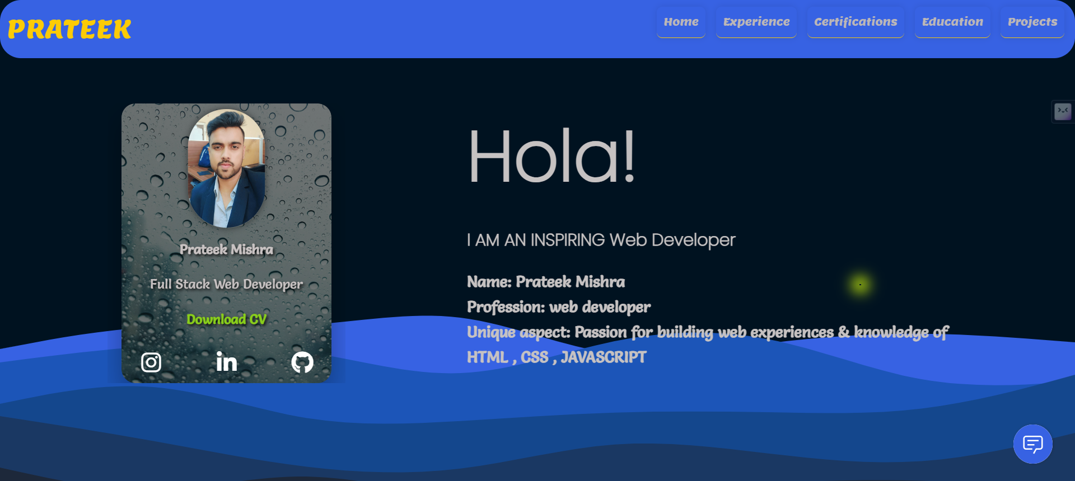

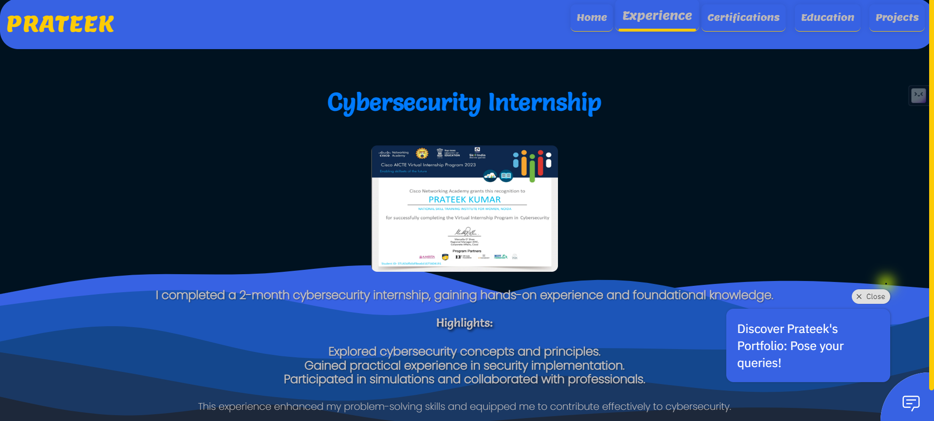

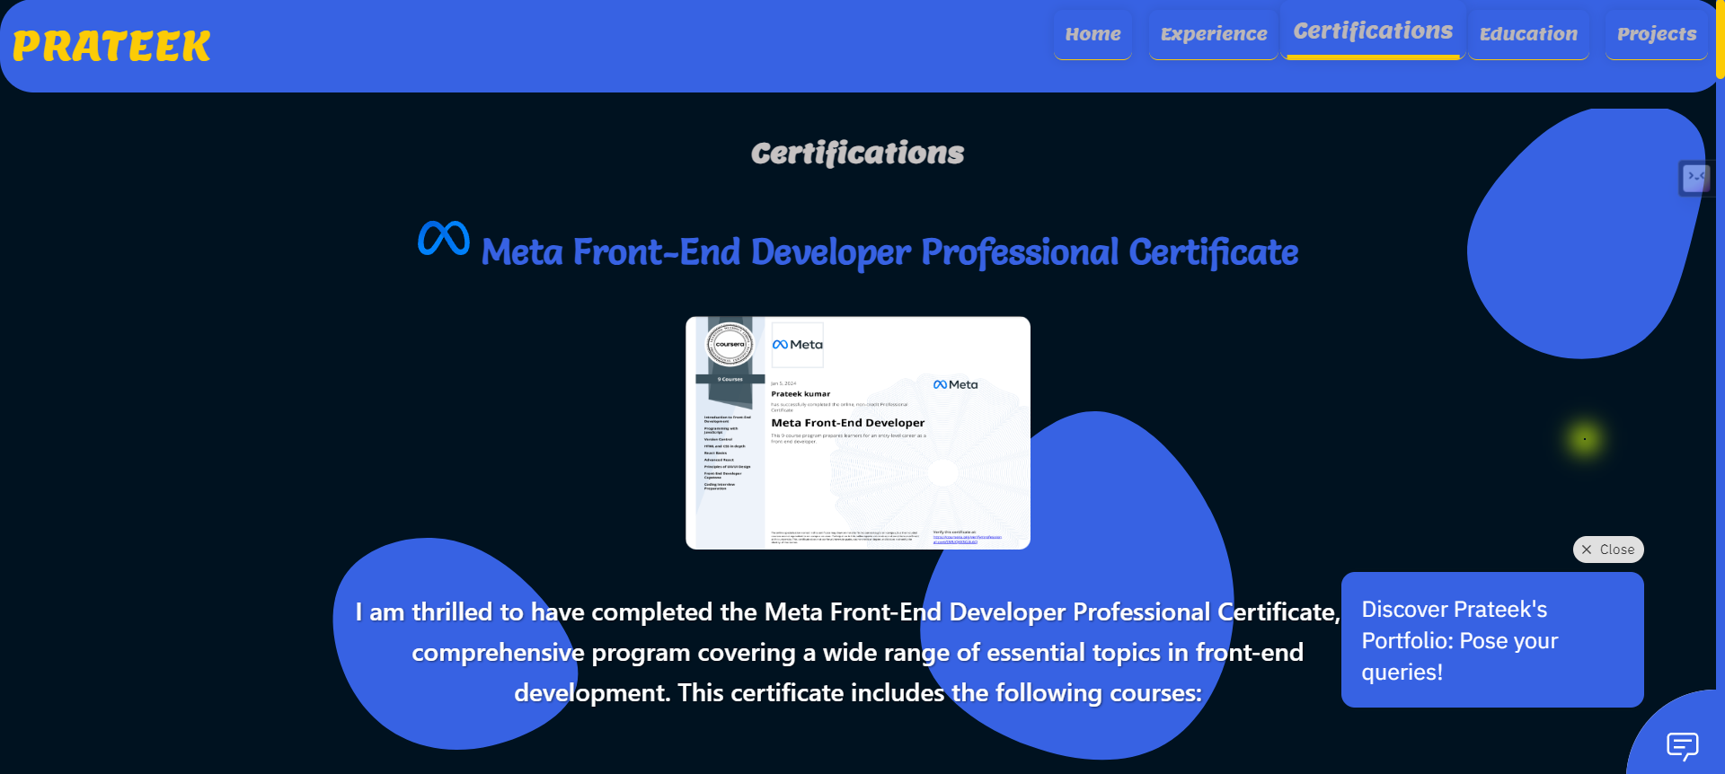

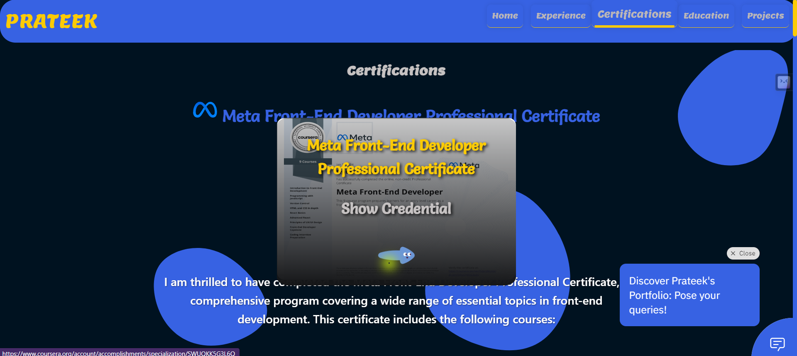

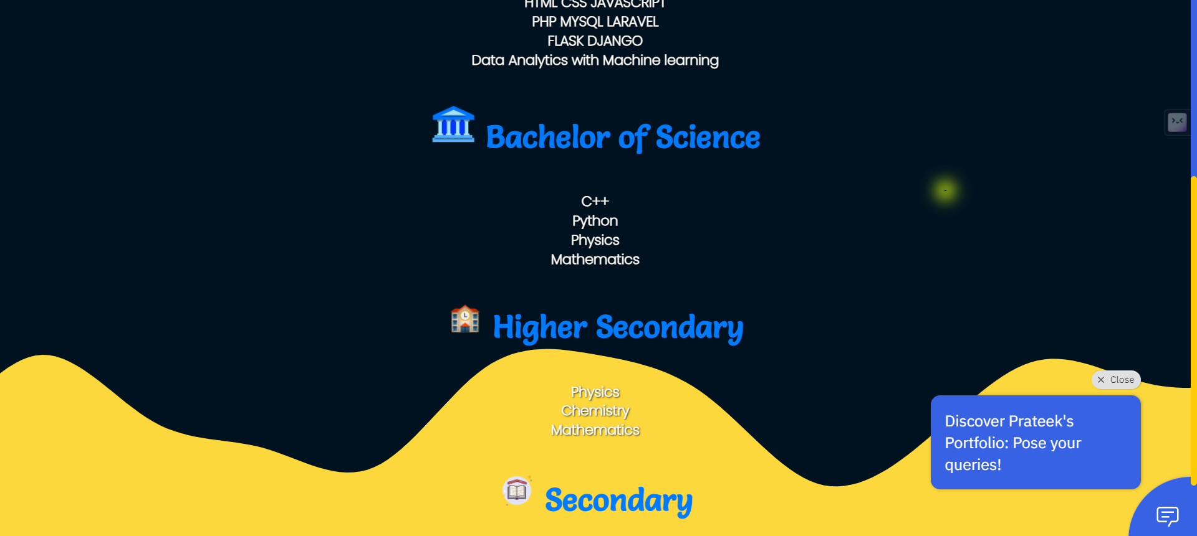

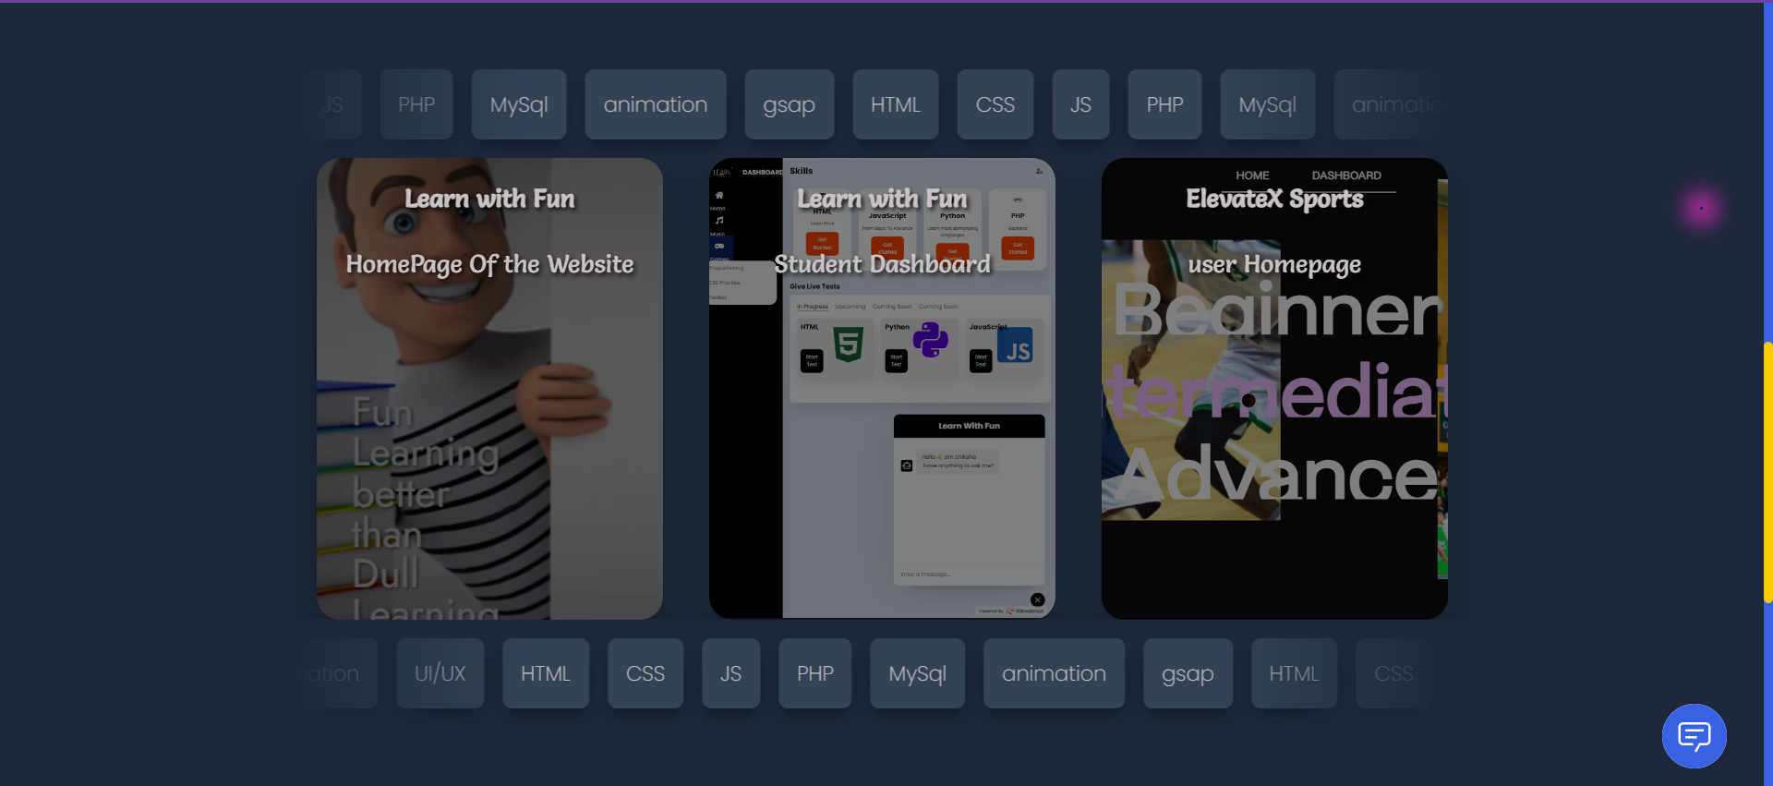

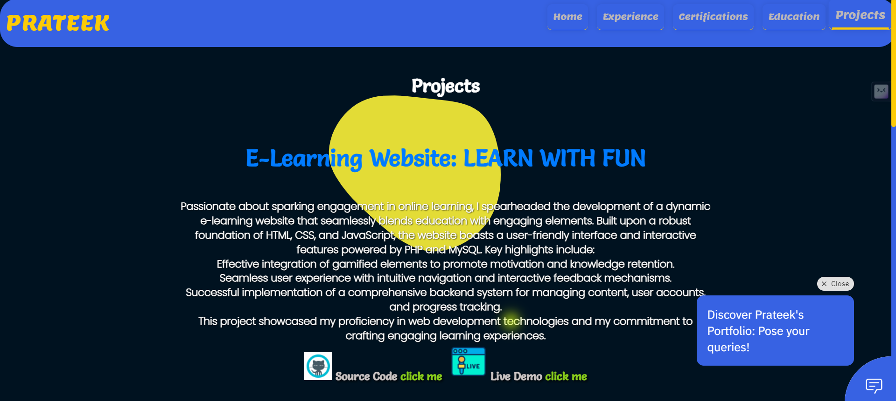

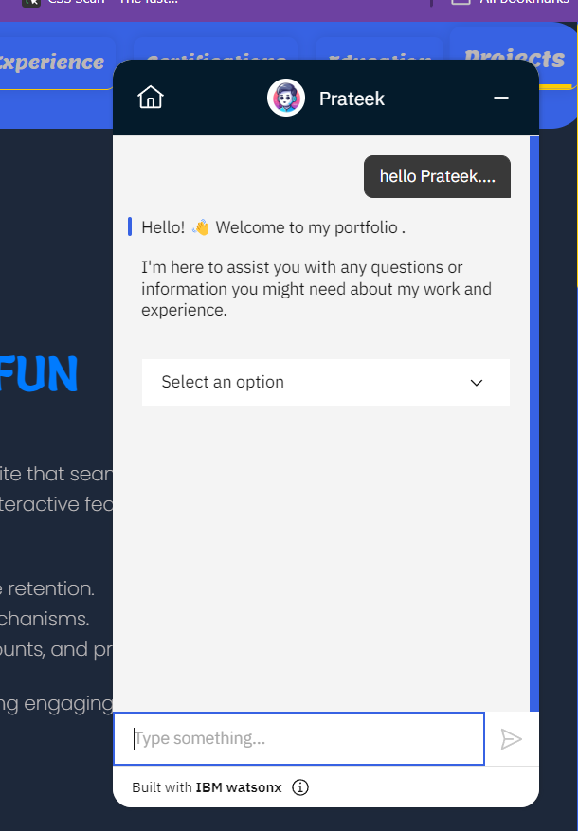

# References

**www.ibm.com - How to Build a Chatbot - IBM Watson Assistant**

[**www.ibm.com**](http://www.ibm.com) **– hosting static website – cloud object storage**

**cloud.ibm.com - Integrating the web chat with your website**